Project Documentation

1. Introduction
Project Title: Smart Library Request Workflow in ServiceNow.

Team Members:
- BHUVANESHWARI K – Team Lead
- DIVYA SREE P – Team Member
- KETHSIYARANI V – Team Member
- NANDHINI V – Team Member
- SUBASRI M – Team Member

2. Project Overview
Purpose:
The Smart Library Request Workflow is designed to streamline library book requests and approvals within ServiceNow. Users can request books, track status updates, and receive notifications, while librarians can manage approvals efficiently. The system also provides dashboards and reports for administrators to monitor book requests and user activity.

Features:
- User login with role-based access (User & Librarian)
- Borrow request submission with validation
- Approval and rejection workflow for librarians
- Email and system notifications for request status updates
- Dashboard displaying total requests, requests by user, and pending approvals
- Monthly and real-time reporting on borrow requests

3. Architecture

Frontend:
- Built with React.js using functional components and hooks
- State management with Redux
- Routing via React Router
- Axios used for API calls to the backend

Backend:
- Node.js with Express.js framework
- RESTful API endpoints for CRUD operations on users, books, and borrow requests
- Middleware for authentication, authorization, and error handling
Database:
- MongoDB collections for Users, Books, and Borrow Requests
- Mongoose used for schema definition and database interaction
- Borrow Requests reference User and Book collections for data integrity

4. Setup Instructions
Prerequisites:
- Node.js
- MongoDB (local or Atlas cluster)
- npm or yarn package manager
Installation:
- Clone the repository: https://github.com/Bhuvaneshwari1242006/smart-library-request-workflow-in-servicenow.git

- Install dependencies:
cd client
npm install
cd ../server
npm install
- Configure environment variables in .env file:
PORT=5000
MONGO_URI=[MongoDB URI]
JWT_SECRET=[JWT Secret]

5. Running the Application
Frontend:
cd client
npm start
Backend:
cd server
npm start
Frontend runs on port 3000, backend on port 5000.

6. API Documentation
Endpoints:
- POST /api/auth/login – User login
- POST /api/auth/register – User registration
- GET /api/books – Retrieve all books
- POST /api/borrow-requests – Submit a borrow request
- PUT /api/borrow-requests/:id/approve – Approve borrow request (librarian)
- GET /api/reports/monthly – Monthly request summary
Example Response:
{
"success": true,
"data": [ ... ]
}

7. Authentication
- JWT-based authentication and authorization

- Tokens stored in local storage and sent in headers

- Role-based access control: User vs Librarian

- Middleware checks token validity and user roles for protected routes

8. User Interface

- Screenshots or GIFs showing:
  - Login Page

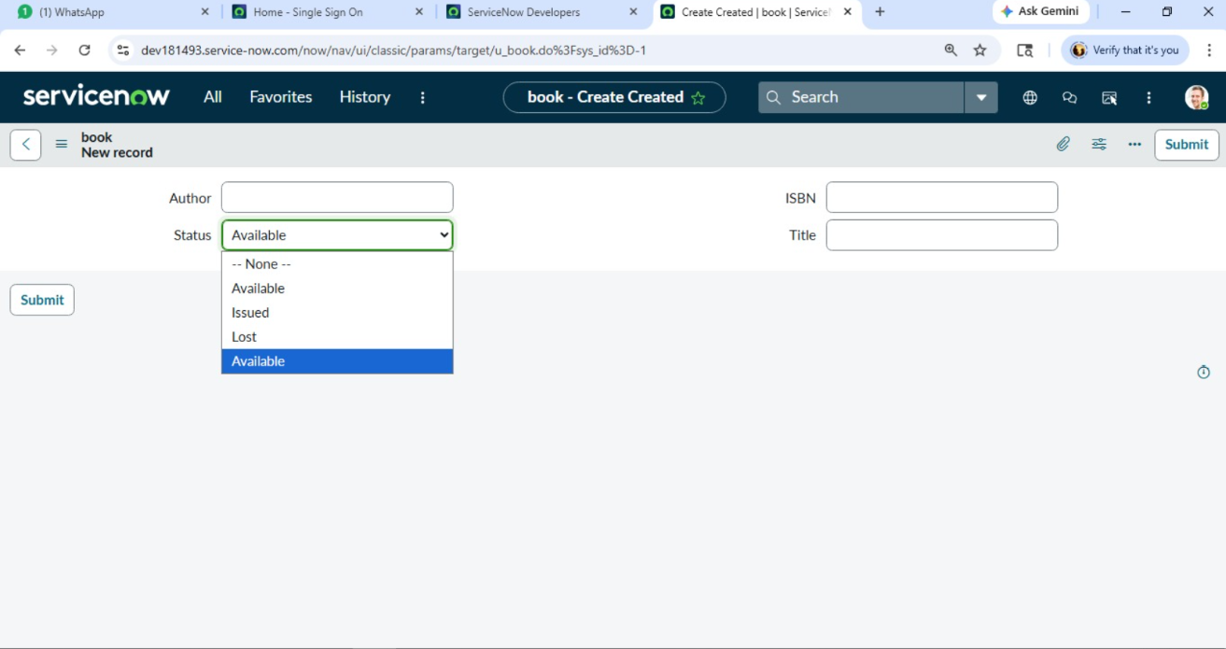

- Borrow Request Form

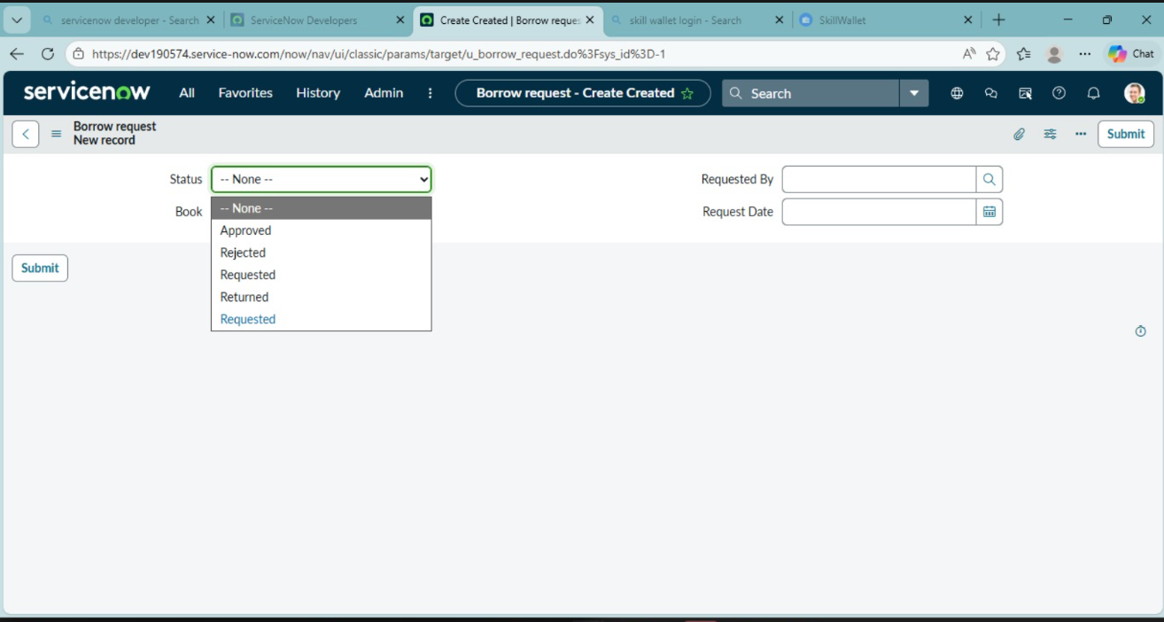

- Approval Dashboard
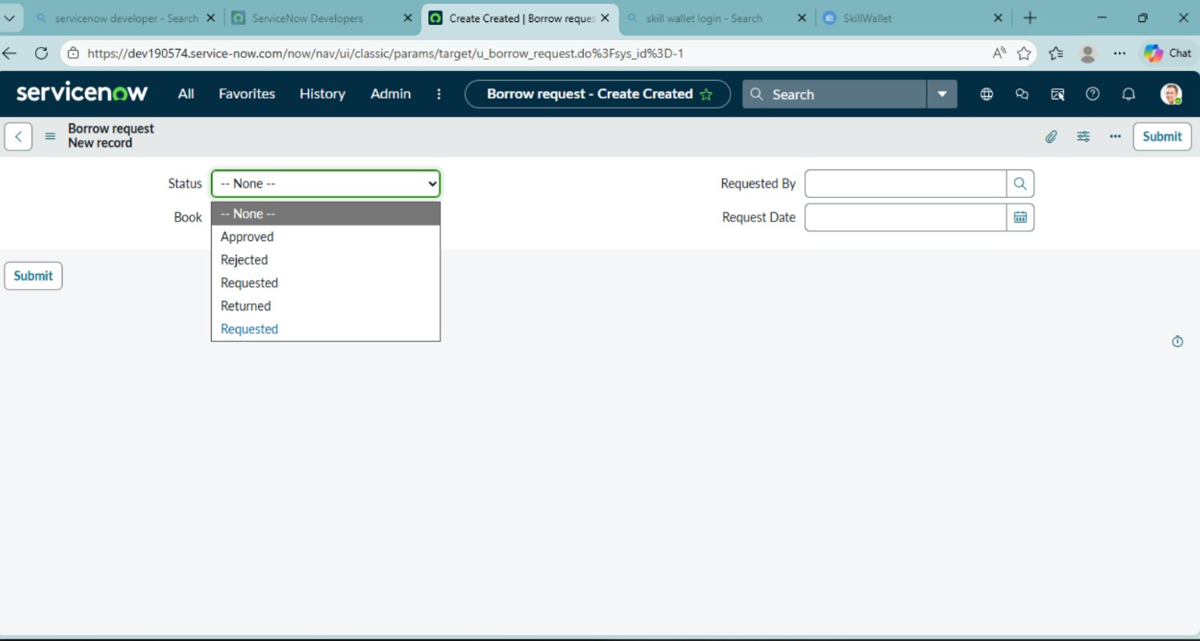

- Reports and Charts
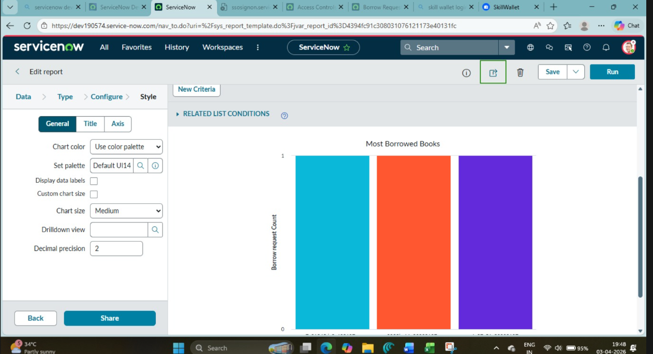

10. Testing
- Backend unit testing using Jest
- API integration testing
- Manual UAT performed for all user workflows

11. Screenshots or Demo
- Demolink: https://drive.google.com/drive/folders/1iIsOUcEJzvbWzj0qfIwTxs_Q9C8Ya1Qo?usp=sharing

12. Known Issues
- Dashboard may experience slight delays with large datasets
- Minor UI inconsistencies on mobile devices

13. Future Enhancements
- Add search and filter functionality for books
- Email notifications for overdue or unreturned books
- Analytics for user activity trends
- Improved mobile responsiveness

